Click start to local Windows and search remote desktop and then open it.

Then click on the Show Options

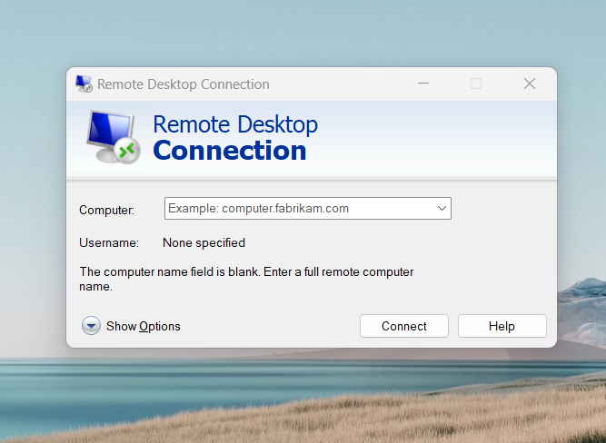

Then Local Resources and More

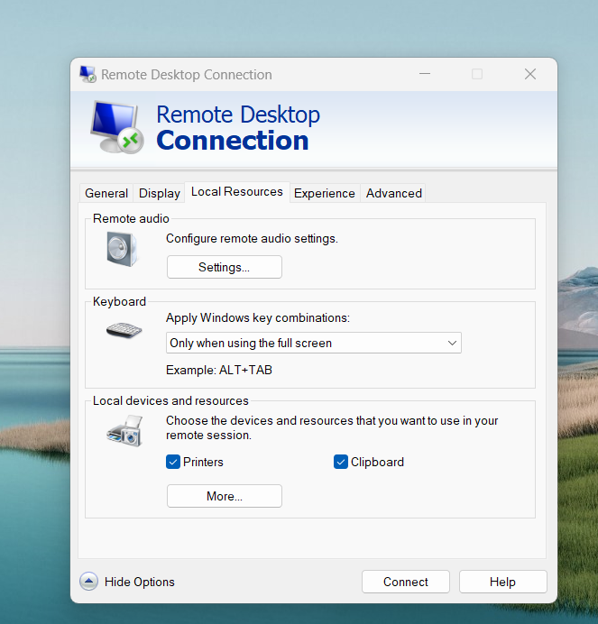

We will be check on the Video cature devices like bellow and then click OK.

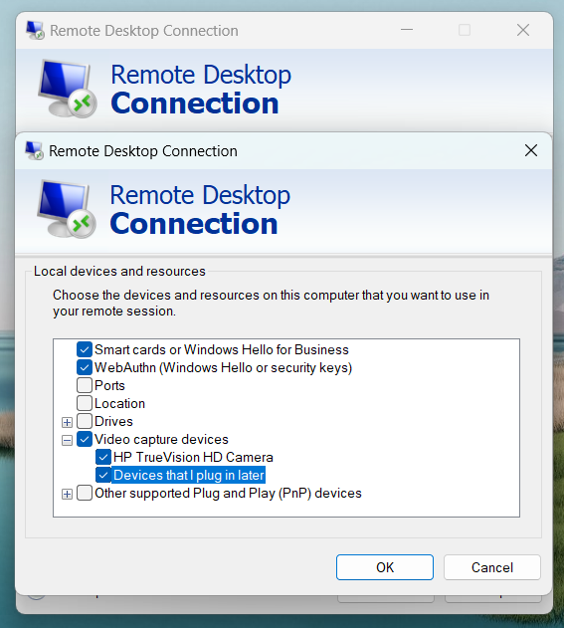

And then again Local Resources and click to Settings

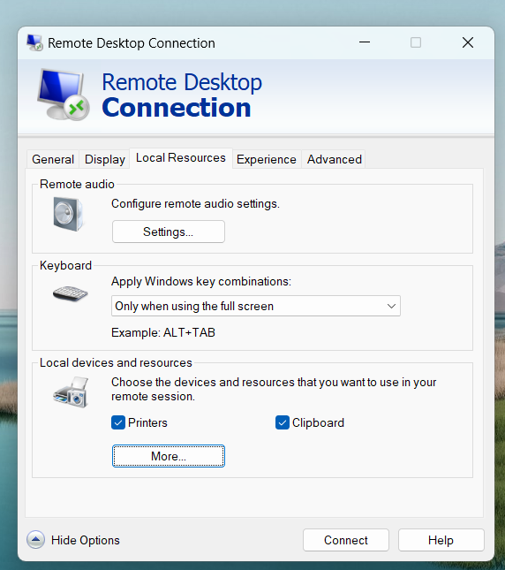

We will check on the “ Play on this computer and Record from this computer” and click OK.

